**BANKING DASHBOARD REPORT**

**Problem Statement :-**

Develop a basic understanding of risk analytics in banking and financial services and understand how data is used to minimise the risk of losing money while lending to customers.

**Solution :-**

With our dashboards which are created using Power BI latest tools helps the company to make a decision based on the applicant’s profile like if the applicant is likely to repay the loan then approving the loan otherwise not.

**About Dataset :-**

This dataset basically contains information about bank details ,various client details which consists of multiple tables which are interlinked with each other through keys like primary key and foreign key.

The various tables are Banking Relationship, Banking-Client, Gender and Investment Advisor.

**Data Cleaning :-**

* Created a custom Income Band column by segmenting raw income values into defined ranges (e.g., Low, Medium, High) to enable demographic grouping and comparison.
* Standardized data types across multiple columns (e.g., converted text fields to categorical, date fields to datetime format) for consistent reporting and accurate aggregations.
* Replaced inconsistent or invalid entries (e.g., missing gender values, incorrect account types) using conditional logic and Power Query transformations.
* Removed duplicate rows and handled null values through filtering, imputation, or logical replacement to ensure clean and complete datasets.
* Applied column renaming and formatting to improve readability and maintain Power BI data modeling best practices.

**Dashboard Overview :-**

The provided Power BI dashboard represents a banking dataset with the goal of analyzing customer demographics, account types, transaction behaviours, and KPIs related to banking operations. The dashboard likely includes multiple pages focusing on operational, demographic, and product-based insights that help stakeholders understand customer engagement and financial trends.

**KPI’S:-**

* **Total Clients:** Total Clients KPI represents total number of clients in banking.

Total Clients = COUNT(‘Banking-Clients’ [Client ID] )



* **Total Loan:** Total Loan gives you information about the bank loan + Business lending + credit cards balance of particular investor , gender.

Total Loan = [Bank Loan] + [Business Lending] + [Credit Cards Balance]



* **Bank Loan:** Bank Loan gives you information what is the loan amount of loan to be repaid by the client to bank.

Bank Loan = SUM(‘Banking-Clients’ [Bank Loans] )

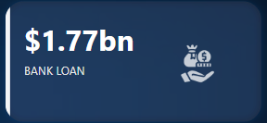

* **Business Lending:** Business lending gives you information about the loan amount given to small business.

Business Lending = SUM('Banking-Clients’[Business Lending] )



* **Total Deposit:** Total Deposit gives you information about the amount deposited by particular investors in bank

Total Deposit = [Bank Deposit] + [Savings Account] + [Foreign Currency Account] + [Checking Accounts]



* **Bank Deposit:** Bank deposit is the money put in the bank.

Bank Deposit = SUM('Banking-Clients'[Bank Deposits] )

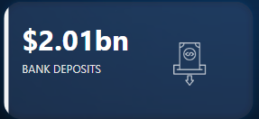

* **Checking Account Amount:** Checking account amount is nothing but which offers easy access to your money for daily transactional needs.

Checking Accounts = SUM(‘Banking-Clients '[Checking Accounts] )



* **Saving Account Amount:** A savings account is an interest-bearing deposit account held at a bank.

Savings Account = SUM(‘Banking-Clients'[Saving Accounts] )



* **Foreign Currency Amount:** Foreign Currency Account means an account held in a currency that is not the currency of India or Bhutan or Nepal.

Foreign Currency Account = SUM(‘Banking-Clients'[Foreign Currency Account] )



* **Credit Cards Balance:** It is the total amount of money currently owned by a cardholder to their credit card bank.

Credit Cards Balance = SUM(‘Banking-Clients'[Credit Card Balance] )



**Visualization & Results:-**

* **Home**

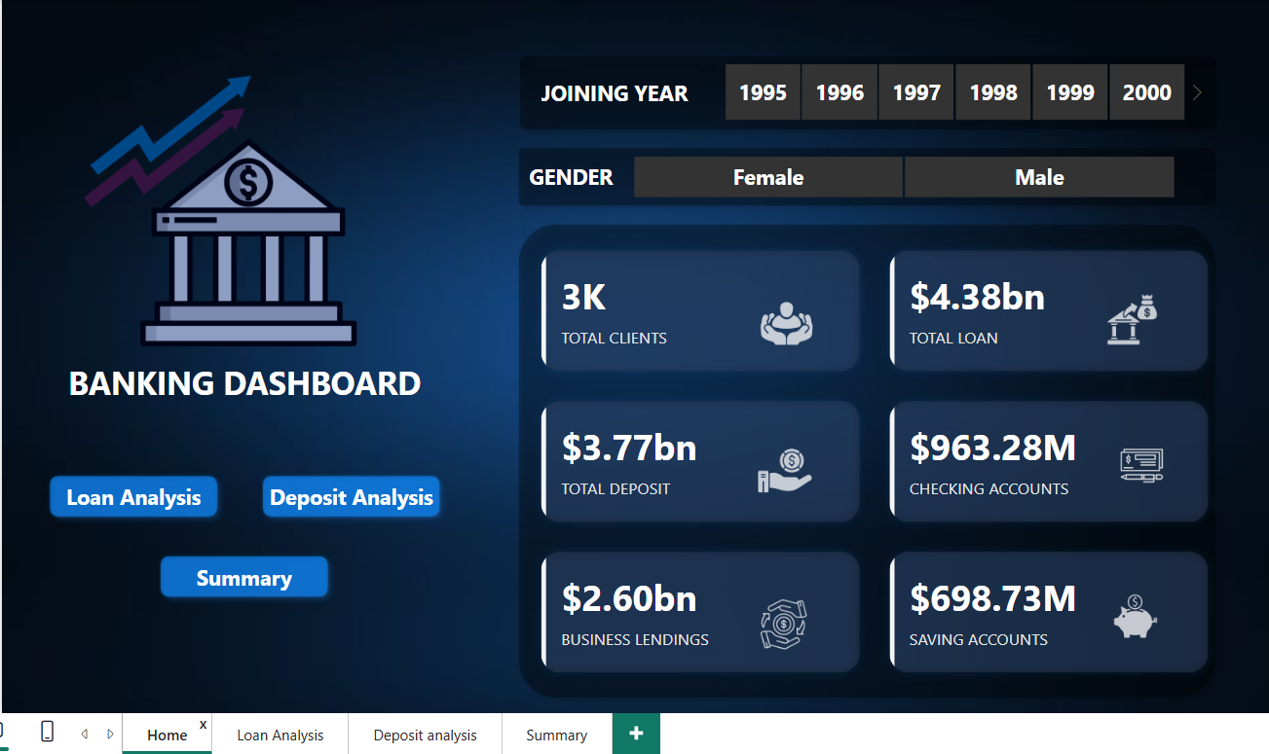

* **Loan Analysis**

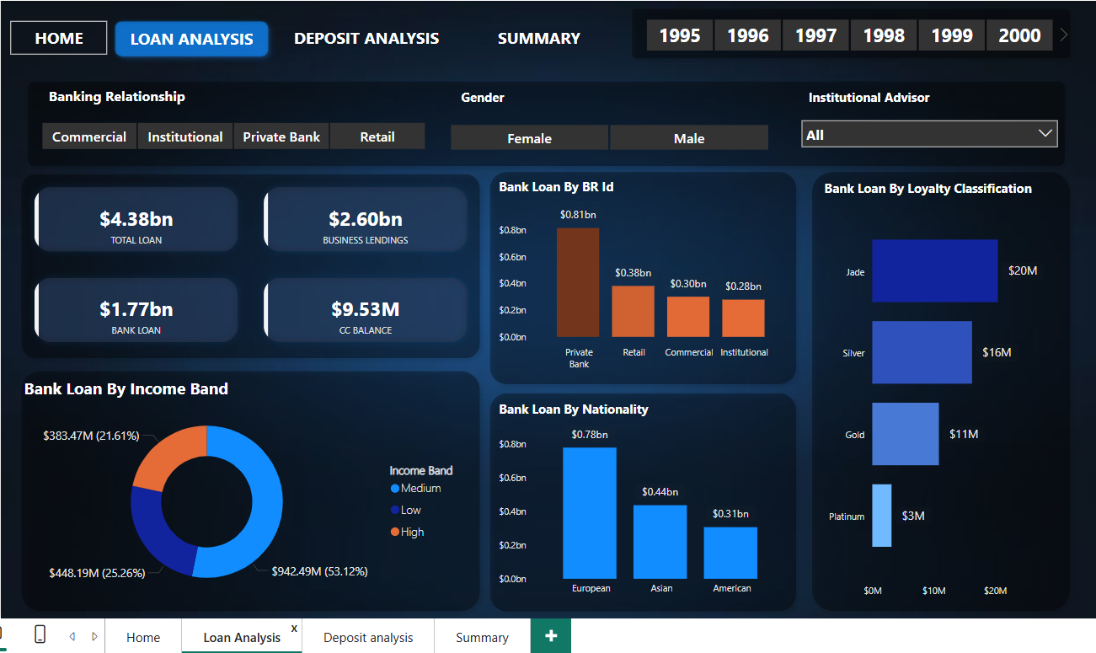

* **Deposit Analysis**

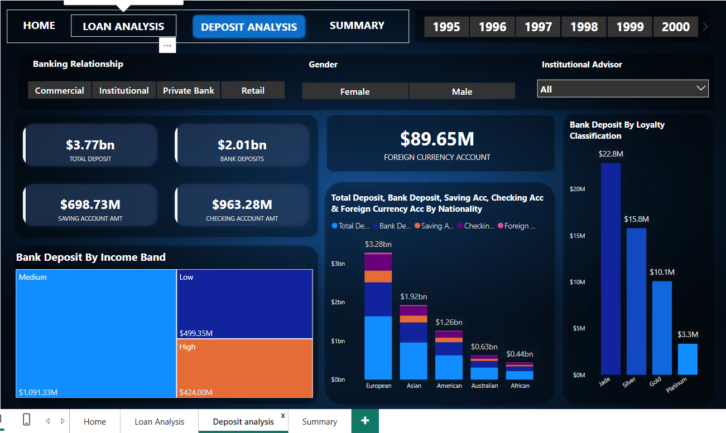

* **Summary**

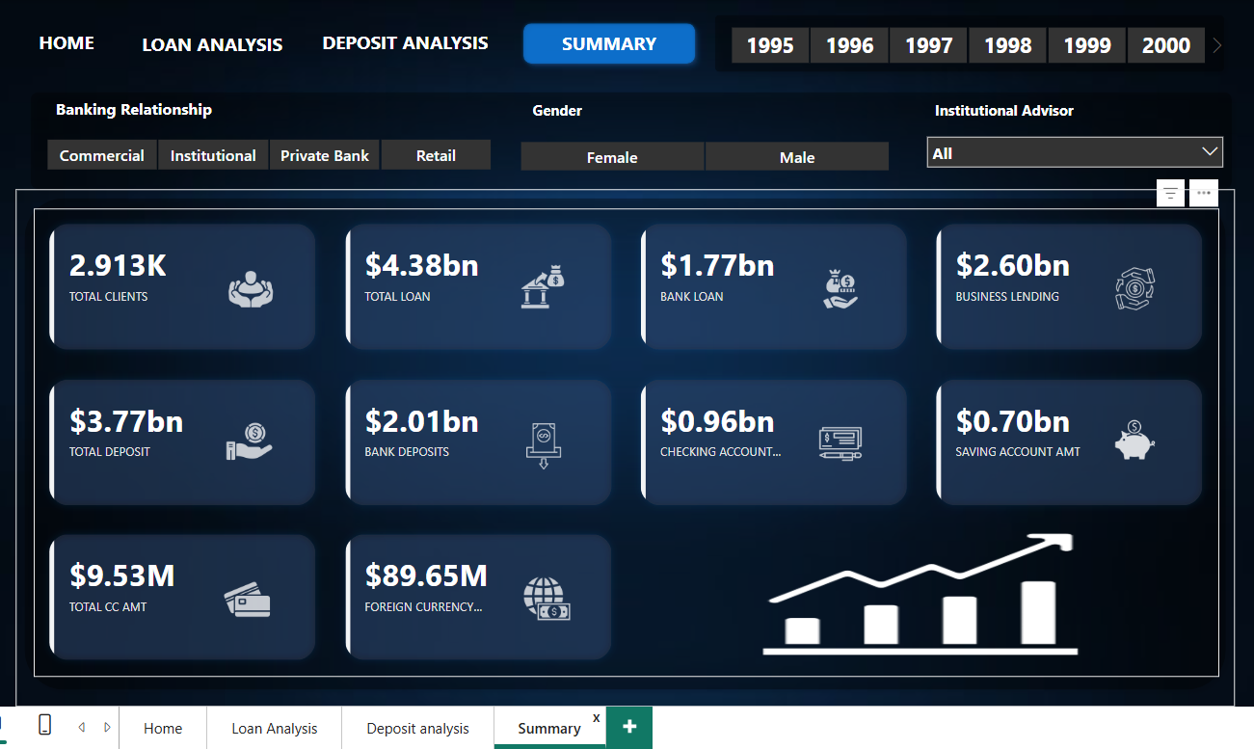

**Conclusion:-**

With these dashboards banks can easily know what is the total loan amount and all other things of a particular investor.

It also helps which type of banks have more numbers of clients as we can see private banks have more number of clients so it can help other banks can build their strategies to increase clients.

It also provides insights about which nationality has highest bank loans.

It gives information about various types of amounts involved in different types of accounts by investors.